**DM2193 Final Documentation**

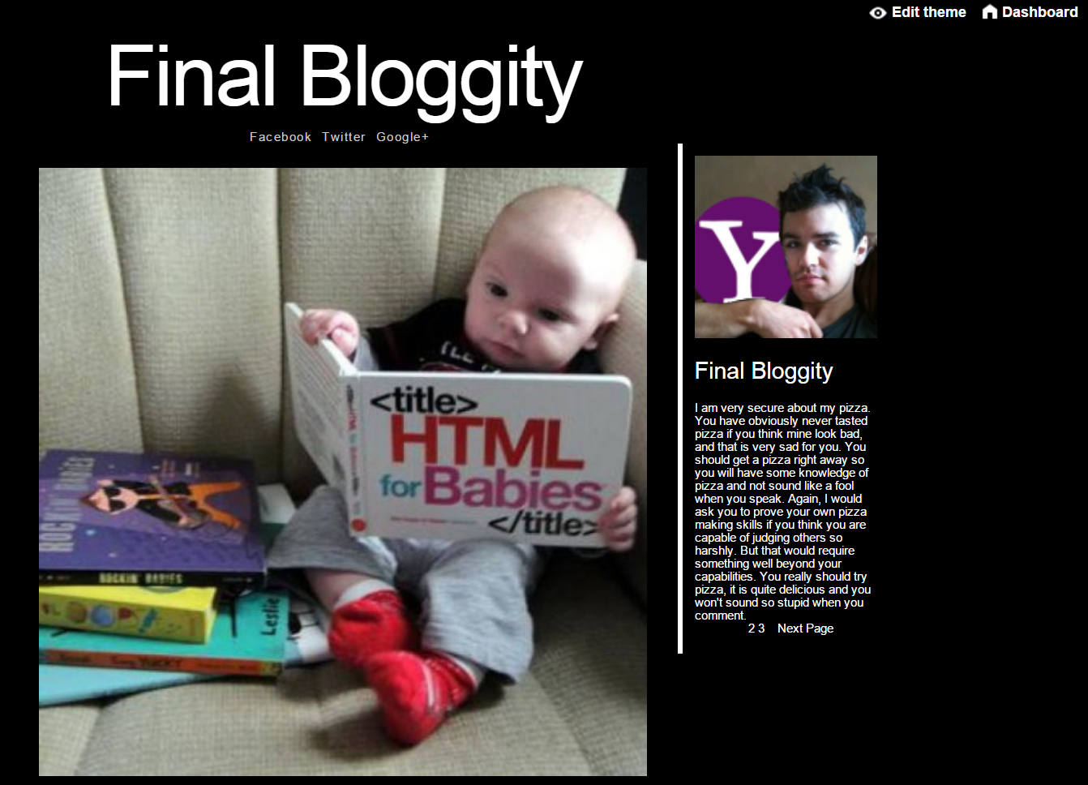

The above screenshot shows the theme at its barebones. It’s a very minimalistic theme that focuses on giving each content equal amount of real estate on the screen. The theme tries to set itself apart from all other themes that try to squeeze as much content into the available real estate as possible. The title of the blog is the biggest aspect of the page and it immediately tells the visitor which blog he or she is in and avoids confusion. Following the title are the blogger’s other social media links so the visitor can easily find the blogger’s corresponding social media outlets. Other than the post itself, the second most important aspect about the screenshot above is the blogger’s description. The description is limited to a certain amount of characters in order to keep with the theme’s minimalistic nature and only sports one profile picture of the blogger. The sidebar is divided by a solid white border to easily distinguish itself from the posts. The sidebar also host’s the page count and the page navigation, but more on this later.

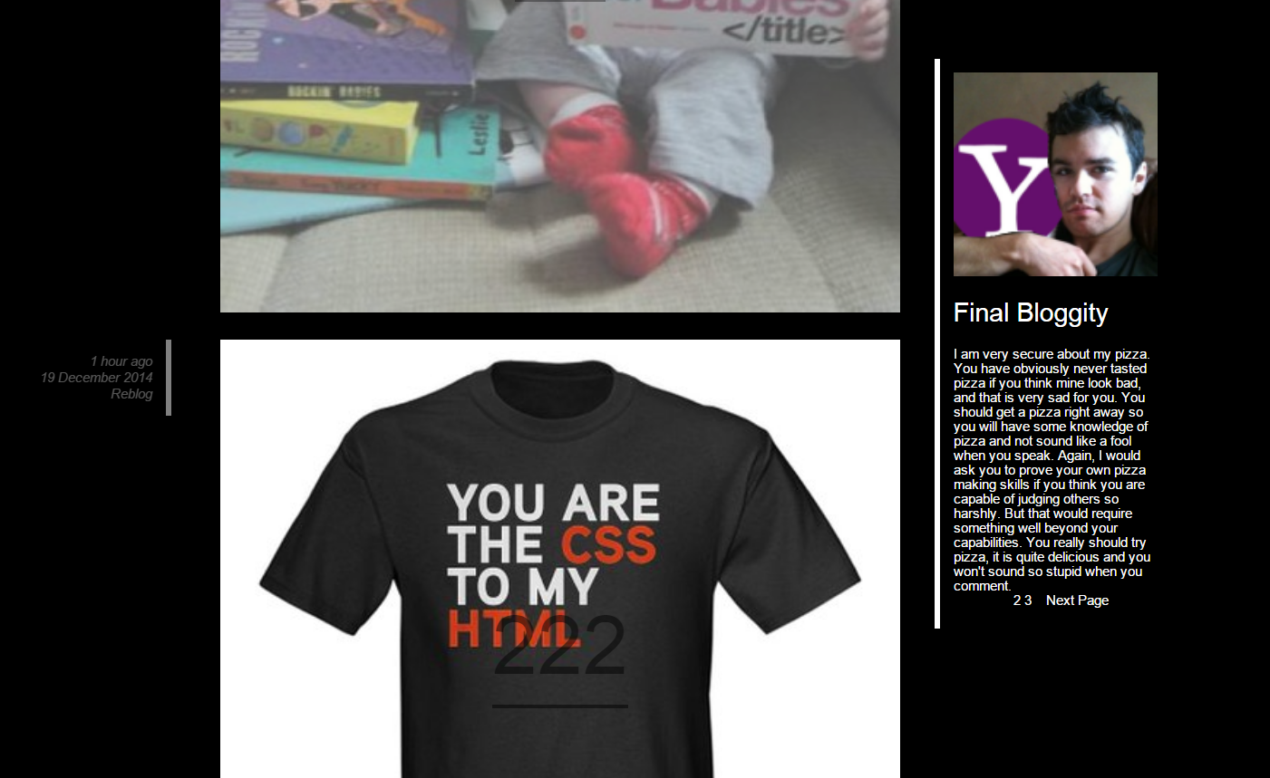

This screenshot shows that when the user scrolls down to the next post, the sidebar’s fixed position on the DOM will allow the user to see the description of the blog no matter where he or she is in the page.

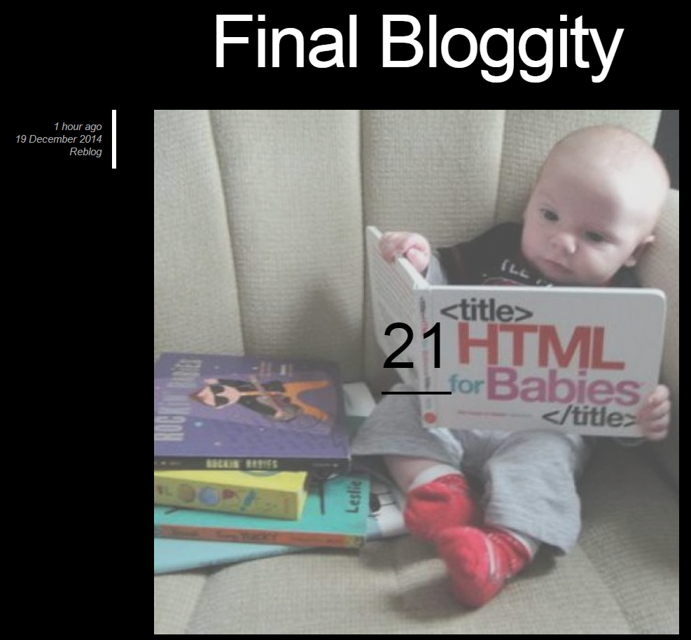

This screenshot highlights some special features about this theme. They will be explored further in the next posts.